Bulletin of Events, Activities and Trends

FoNTRA Newsletter - March 2026

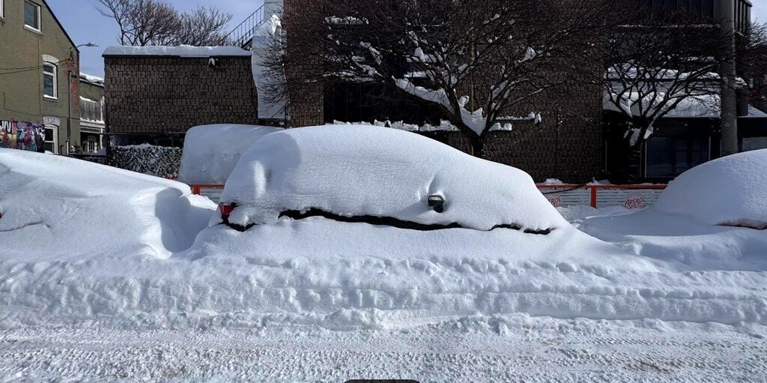

Snow Day - January 25, 2026 Photo Credit: Weather Network

Dear Association Contact
This email is the March edition of eNewsletter - with information on upcoming meetings and other activities across the City.

On January 25, 2026, Pearson saw 46 cm of snow in 24 hours, the largest single-day snowfall ever measured there. Downtown Toronto saw 56 cm on the same day.

The lead article in this edition focuses on the MTSA review report that is scheduled for the Planning and Housing Committee. The MTSA proposal is complex, and the impact of the proposed changes will be felt across the City. We encourage all residents to learn more about the proposed zoning changes.

We also highlight the appeal of the school exclusions in 'Avenues Policy Review' and a proposal from Mayor Chow to conduct another review of the Committee of Adjustment.
Feel free to share the contents of this newsletter with fellow residents and neighbours.
Best regards,
Geoff Kettel

MTSA ROLLOUT

Residents awaiting the City Planning Report on Major Transit Station Areas (MTSAs)

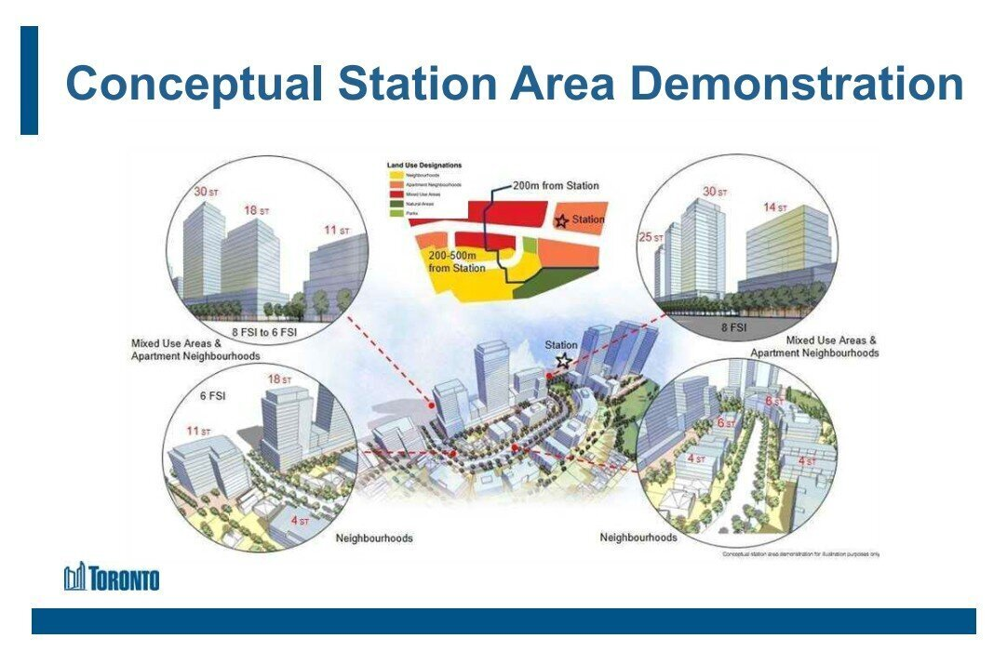

See Planning Presentation with this LINK

THERE ARE MANY ZONING LAYERS AT PLAY:

City Planning was very active in 2025, introducing new zoning regulations:
- City-wide multiplexes, with fiveplexes and sixplexes allowed as-of-right in some areas
- New Major Streets were classified across the city
- New Avenues were identified, with implementation in phases - beginning with Wards 9 and 11
- Planning for the implementation of zoning changes to MTSA areas.
There are complex relationships between the zoning changes listed above.

THE MAPS AND THE COMMUNITY CONTEXT:

The province approved the new MTSA areas in August 2025, and the City of Toronto has released maps detailing the areas. The maps must be read with reference to the City's Official Plan and zoning maps, as the Official Plan identifies the key land use designation categories of Neighbourhoods, Apartment Neighbourhoods and Mixed-Use areas.

Find out more HERE.

WHAT'S AT STAKE:

120 MTSAs have been approved by the province, and the approvals have increased the building heights and densities allowed within the major transit service areas. Many parts of the city may see new 20-storey and 30-storey towers built as a result of the new provincial regulations.

Residents should assess the impact of these changes on their properties, their streets and their neighbourhoods.

Key recommendations from various residents' associations include the following:
- Clarify the treatment of properties that are zoned for Industrial, Employment and Institutional use.
- Need to revisit and extend the Strategic Parking Framework for the City of Toronto (2025) to include the impact of the MTSAs
- Need to update the Tall Building Design Guidelines (2013) to reflect the large-scale introduction of 20-storey and 30-storey towers.
SHARE YOUR VIEW:

The City Planning team has asked for feedback by February 19th, but this should not be considered a limitation on residents seeking information and providing feedback.

There is no PHC meeting in March, and we can expect the MTSA report to be tabled for PHC review on either April 14th or May 7th.

Be prepared to review and respond to the final MTSA review report in the first weeks of either April or May. Work together with other organizations and coalitions to share information and formulate joint responses.

AVENUES POLICY REVIEW

TDSB and TCDSB appeal the School Lands Exclusion in the Avenues Policy Decision

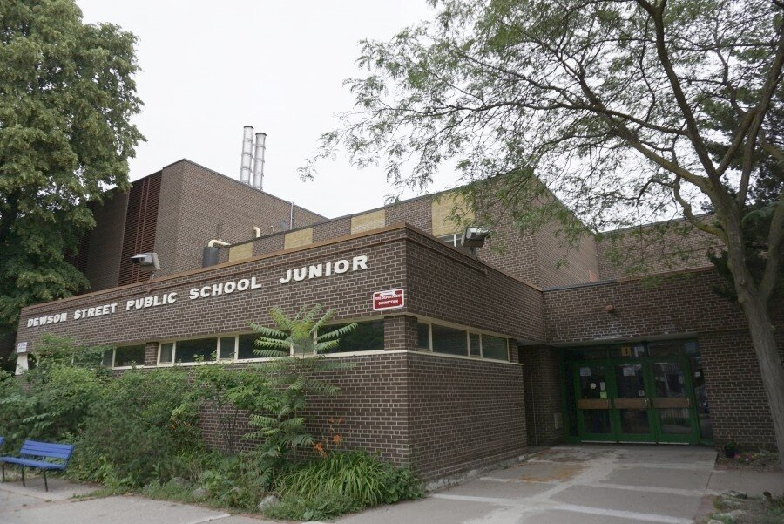

Photo Credit: ACO

CITY COUNCIL MADE A DECISION ON DECEMBER 16TH OF 2025:

Here are the two items related to School Lands.
- City Council adopt Official Plan Amendment 862 for lands on Avenues within Wards 9 and 11 outside of Protected Major Transit Station Areas in accordance ... amended by removing the lands municipally known as 65 Concord Avenue, 25 Dewson Street, and 380 Ossington Avenue ...
- City Council direct the Chief Planner and Executive Director, City Planning, to remove public school properties from future stages of Phase 2 of the Avenues Policy Review.
The decision reflects input from broad feedback from parents in Ward 9 and 11, and concerned residents across the city.

SCHOOL BOARDS APPEAL THIS DECISION:

The Toronto District School Board (TDSB) and the Toronto Catholic District School Board (TCDSB) have separately filed appeals to City Council's decision to exclude school properties from consideration for upzoning to Apartment Neighbourhoods or Mixed Use areas. We note that providing more permissive zoning for school lands will increase the value of these lands, and it is uncertain why school boards are taking legal action to secure this upzoning.

Find out more about the City Council decision HERE.

MORE EROSION OF CITY POWERS:

Residents worry that this action will have unforeseen consequences by introducing school properties into the speculative land market. We note that school properties often act as community hubs for recreation facilities and day care centres.

FOLLOW THIS APPEAL CLOSELY:

Resident associations should follow this appeal closely, as changing the outcome in Ward 9 and Ward 11 will reset the pattern for moving properties from public institutional use to commercial mixed uses.

COMMITTEE OF ADJUSTMENT

Mayor Chow calls for Committee of Adjustment (COA) Changes after Recent Decision

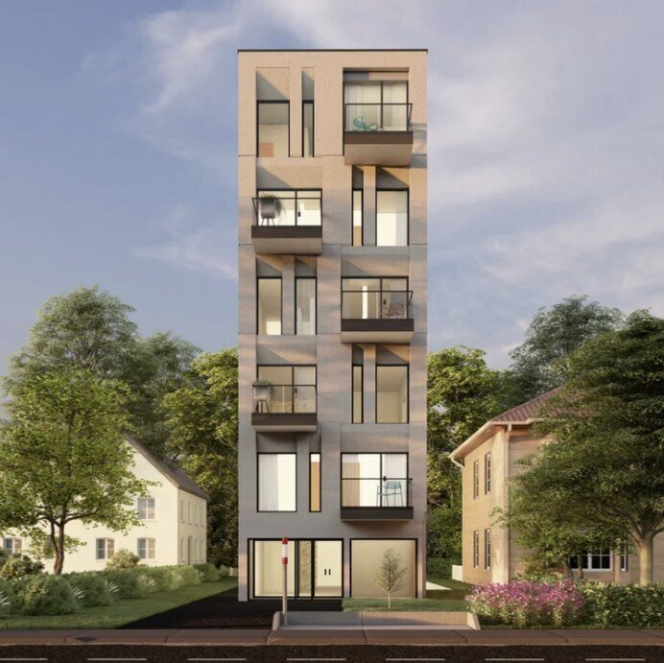

Image Credit: Noam Hazan Design Studio

APPLICATION REFUSED FOR SIX-STOREY WITH 10 UNITS:

On January 14, 2026, a Committee of Adjustment hearing was held to adjudicate a request for variances for a proposed development at 397 Pharmacy Ave. The development was for a six-storey apartment with 10 units on a single lot and seven variances were requested.

The application was unanimously refused by the COA panel, and the applicant has appealed this decision to the Toronto Local Appeal Body (TLAB).

MAYOR CHOW CALLS FOR ANOTHER REVIEW OF THE COA:

Mayor Chow submitted a letter dated February 25th to the Planning and Housing Committee for the meeting held on February 26th. The Mayor's letter noted that.

"Some recent CoA hearings and decisions have raised questions from
stakeholders on how the CoA applies Council-approved policies and CoA member's approaches to evaluating variances."

The Mayor's request (Item PH28.14) was recommended to City Council after a limited discussion. This item will appear on the City Council meeting agenda for March 25, 2026.

The Mayor's letter requests that the review should "engage industry, builders, planners, and other users and stakeholders of the Committee of Adjustment and report in Q2 2026 with preliminary findings ..."

View Mayor Chow's letter HERE.

Find out more about the application HERE.

COA IS IN THE MIDST OF AN IMPROVEMENT INITIATIVE:

The City engaged KPMG several years ago to conduct a review of Committee of Adjustment processes, and an improvement initiative has been underway for the past two years.

It is surprising that yet another COA review has been requested without reference to the ongoing work at the COA.

ADD YOUR VOICES TO THIS DISCUSSION:

Residents' associations are often engaged in Committee of Adjustment proceedings and should participate in this discussion. Comments on this item PH28.14 may be helpful, and we should ask to be invited to the review activities for this program.

Community Consultations

Review of Updated Mid-Rise Building Design Guidelines

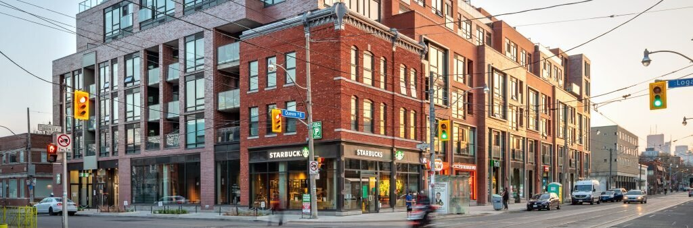

Photo Credit: City of Toronto

The City of Toronto is hosting two online public consultation meetings for residents to learn more about the updated Mid-Rise Building Design Guidelines. Staff will present the updated guidelines, seek feedback, and respond to questions.

Directions for joining the event will be provided to you by email after you register for this event. To find background information, check the
Mid-Rise Building Design Guidelines

VIRTUAL MEETINGS:

Date: Wednesday, March 11, 2026
Time: 10:30 a.m. – 12:00 p.m.

Wednesday Registration

Date: Thursday, March 12, 2026
Time: 6:30 p.m. – 8:00 p.m.

Thursday Registration

Scrolling News

We are adding a new feature to our monthly newsletter where we scan news articles from local news sources and provide links to these articles below.

Leaside residents accuse developer of cutting down trees in the middle of the night

A Toronto developer is being accused of chopping down mature trees in the middle of the night, bypassing bylaws meant to protect city greenery, and it’s not the first time they have been accused of skirting the rules.

Link to Article

Understanding the Eglinton Crosstown in Seven Illustrations

From Shohei Ohtani’s salary to the tunneling rate of a mole—an unorthodox guide to the numbers behind Toronto’s newest transit line.

Link to Article

In the weeds with new transit station area zoning

Blanket “as-of-right” zoning across the City is the new planning regimen in Toronto. As-of-right multiplexes (fourplexes in Ward 15), garden suites, and laneway suites are now permitted in the Neighbourhood-designated areas under the Enhanced Housing Options in Neighbourhoods (EHON) program.

Link to Article

